**MUX Project Using VHDL**

**MdShahid Bin Emdad**

**February 13th, 2022**

**CSC 34200/34300**

**Table of Content**

Objective:

Description of Specifications, and Functionality:

Explanation:

Conclusion:

# 

# Objective:

The objective of this assignment is to create a digital circuit using VHDL by following an introductory tutorial of Quartus and subsequently to create two 2:1 multiplexers (1. where each signal is one bit and 2. where each signal is 32 bits and the selector signal is one bit) by VHDL.

# Description of Specifications, and Functionality:

The digital system I used in this assignment is Quartus Prime 20.1.1 and ModelSimSetup-20.1.1. There two packages needed are cyclonev and cyclonevi (both versions are 20.1.1). In the VHDL editor, I wrote my VHDL code to get the circuit output.

**I. Introtutorial**

First, we I find the software in my Windows OS.

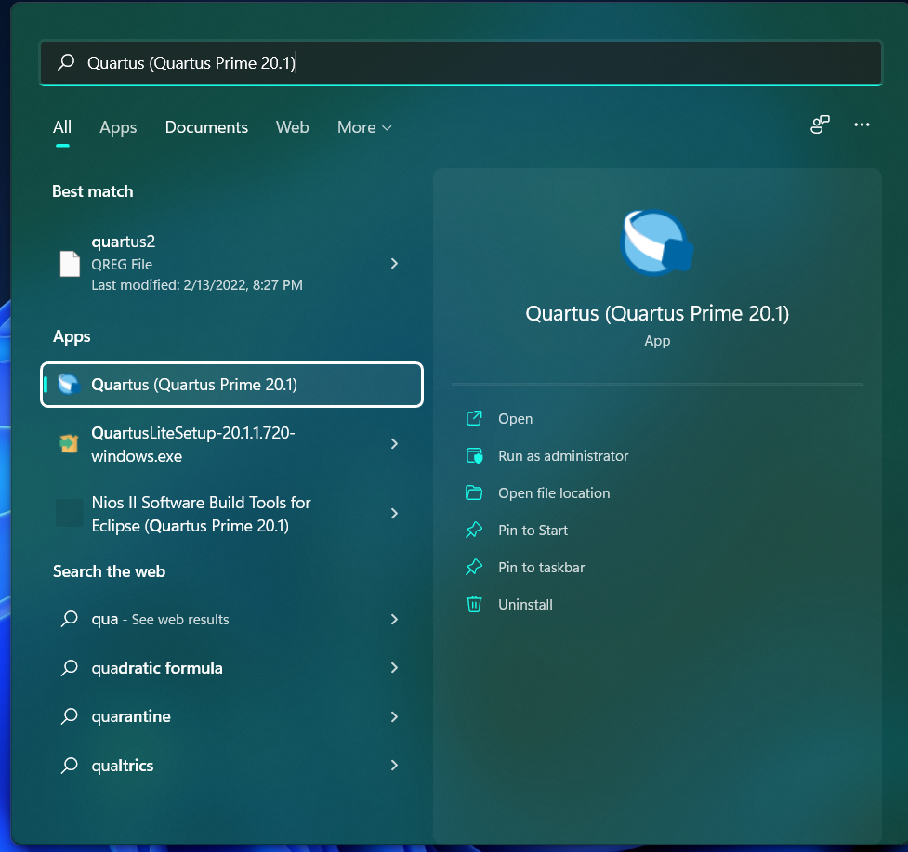

Figure 1: Quartus Software

In figure 2, the file menu is visible on the left side of the image.

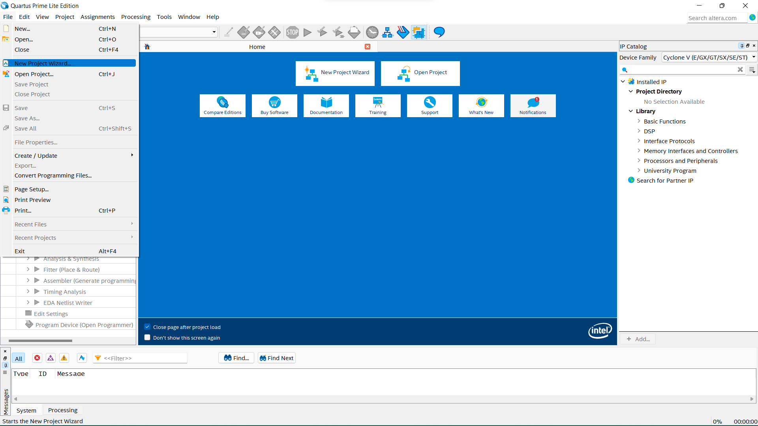

Figure 2: File Menu

In figure 3, I clicked on working directory to choose where to keep the project.

Figure 3: Project folder location

In figure 4, we make the ***introtutorial*** folder where all the project file will be stored.

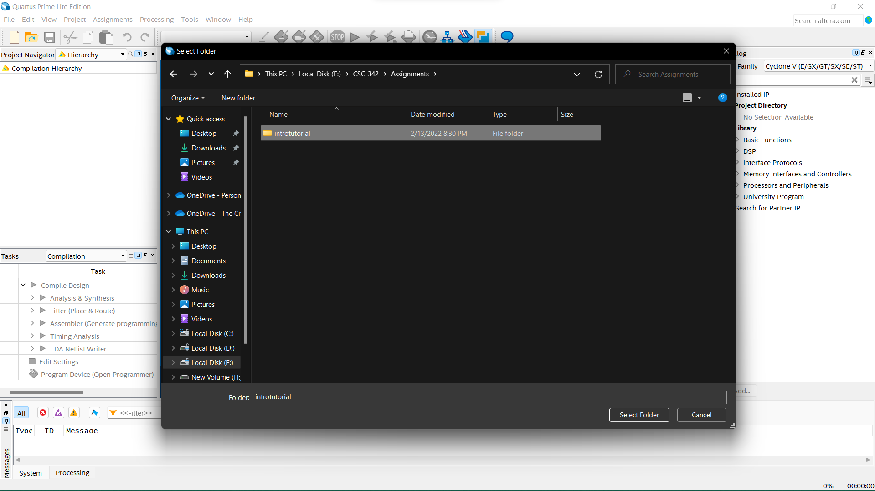

Figure 4: Project directory

In figure 5, I gave the entity name “***Emdad_MdShahid_02_13_2022_light***”.

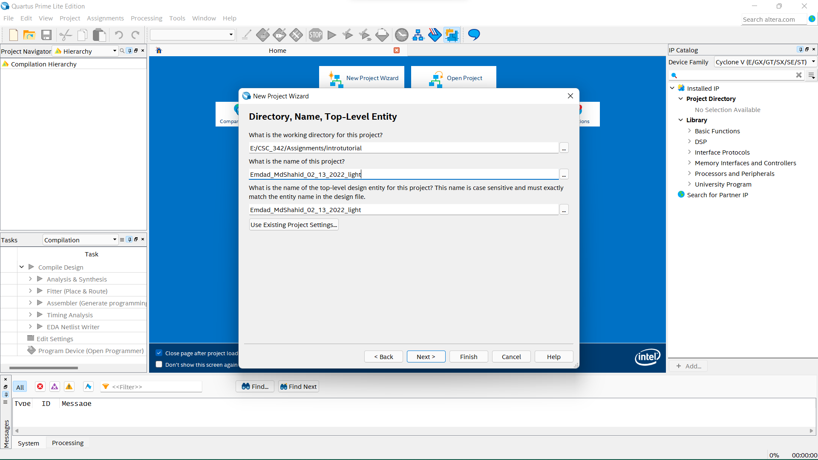

Figure 5: Entity Name

In figure 6, I was instructed to choose a project template but I did not have any project, so I selected empty project.

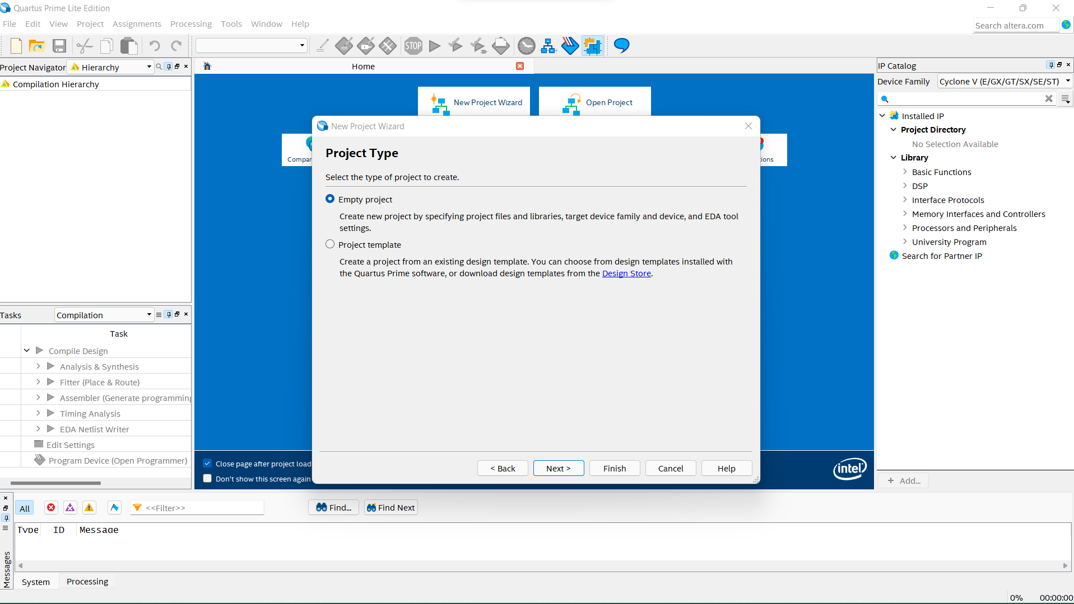

Figure 6: Project type

In figure 7, I was instructed to add any existing VHDL file. I did not have any so clicked next.

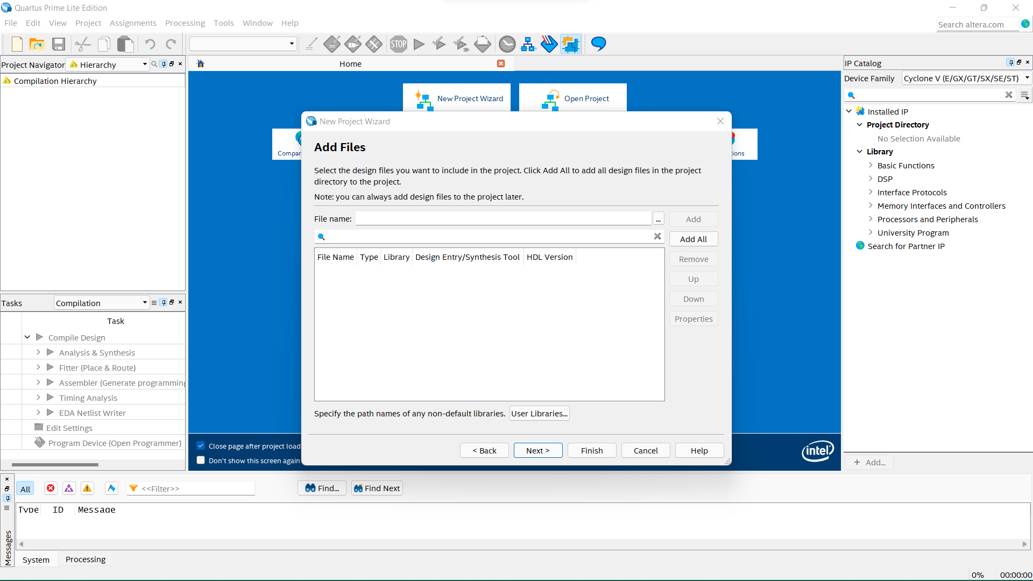

Figure 7: existing VHDL file adding

In figure 8, I was instructed to choose my device family which was already downloaded before installing.

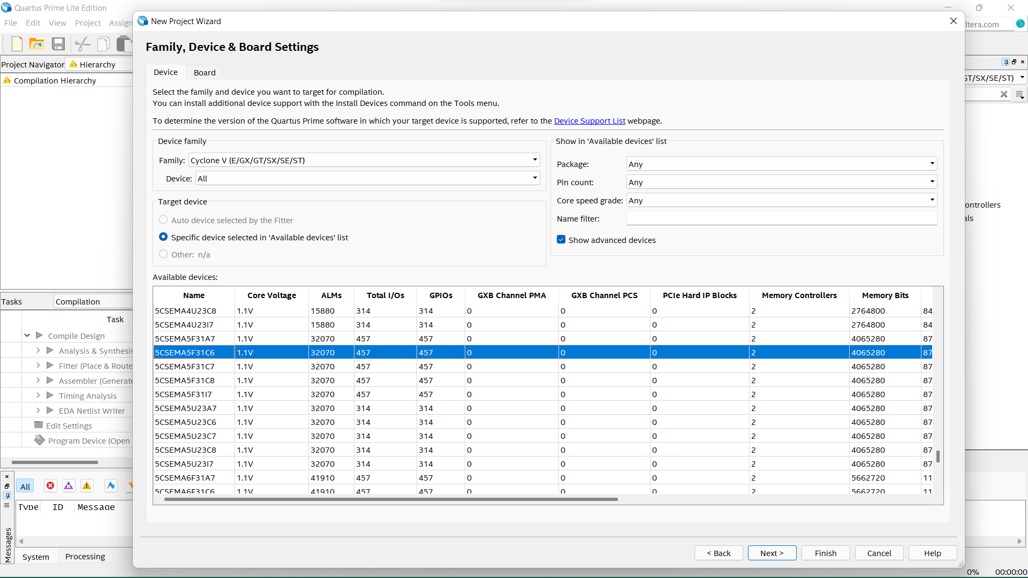

Figure 8: Device and Board Setting

In figure 9, there are EDA tool setting, I did not have any.

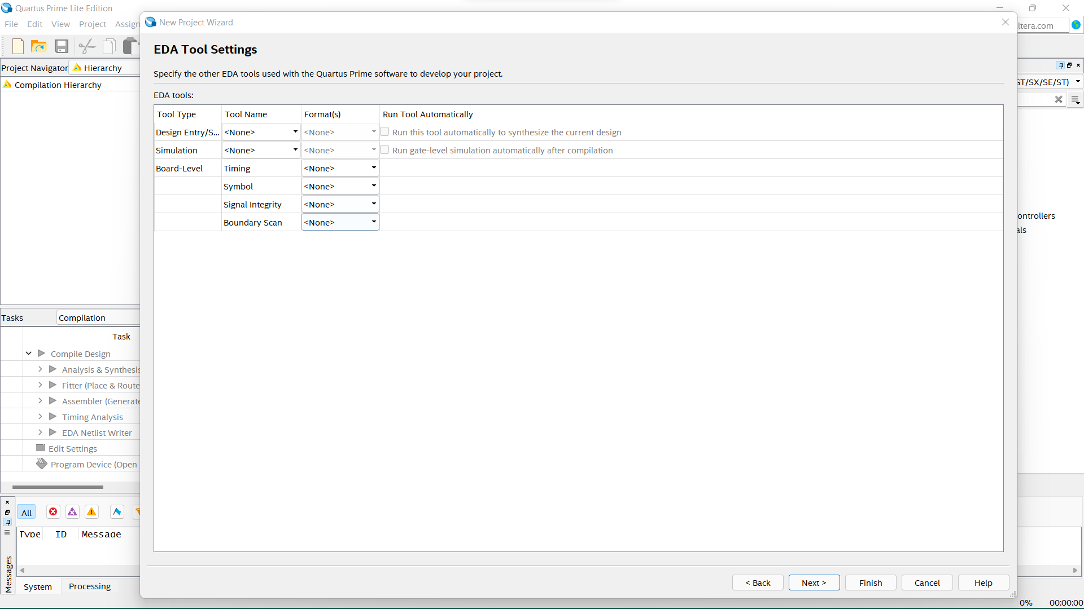

Figure 9: EDA Tool setting

In figure 10, here is my summary specs for my project with all the details.

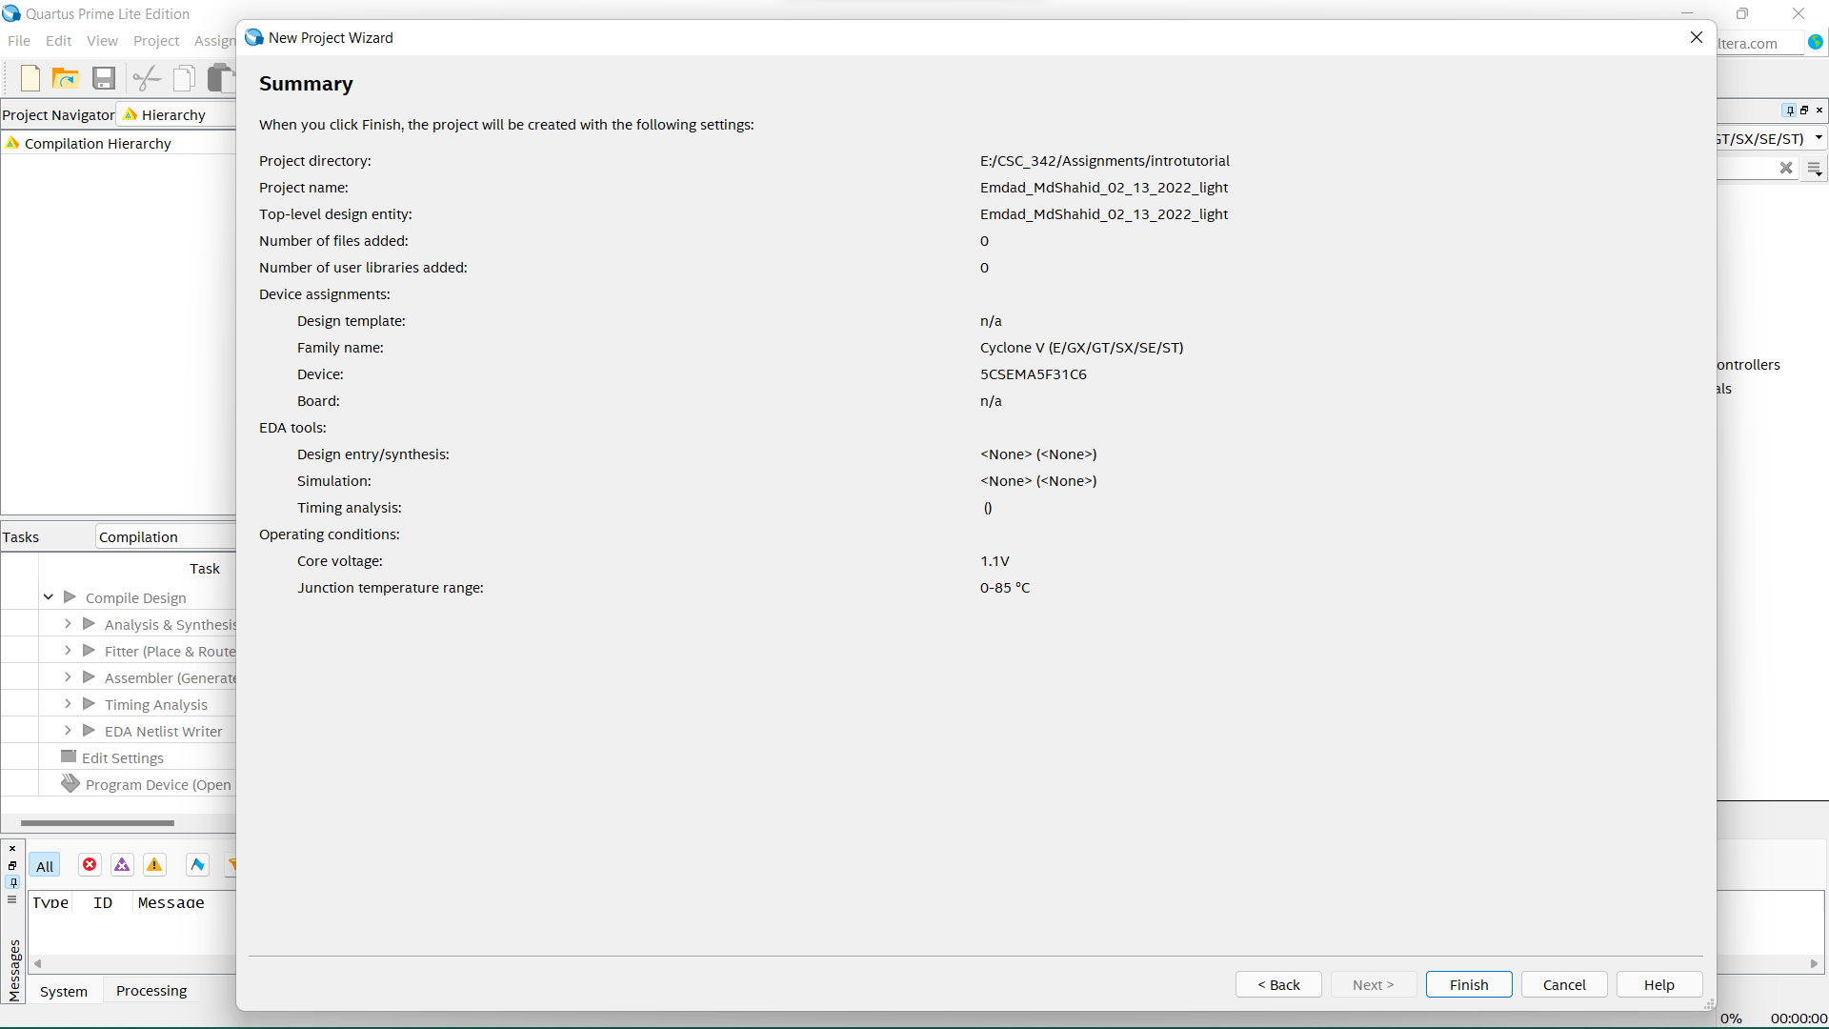

Figure 10: Summary Page

In figure 11, we can see the Quartus home page.

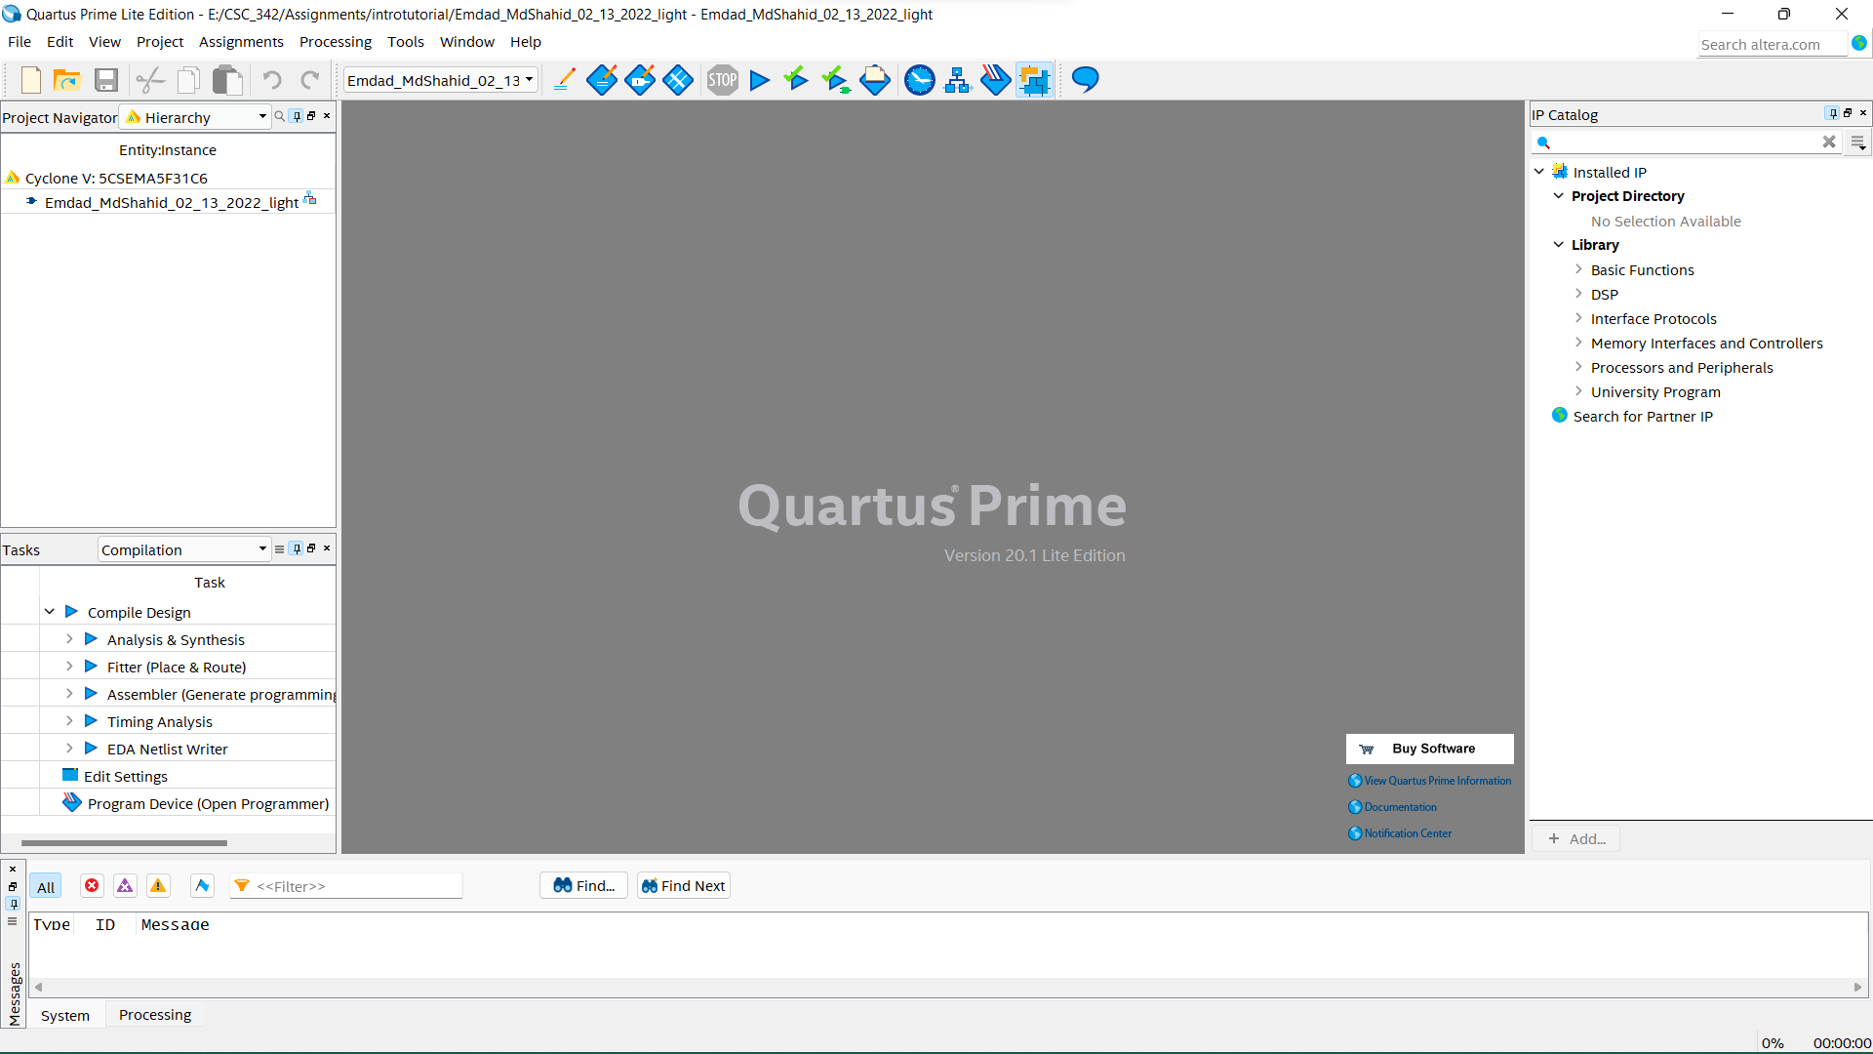

Figure 11: Quartus Home Page

In figure 12, I clicked on ***File*** again and then new to get the VHDL editor.

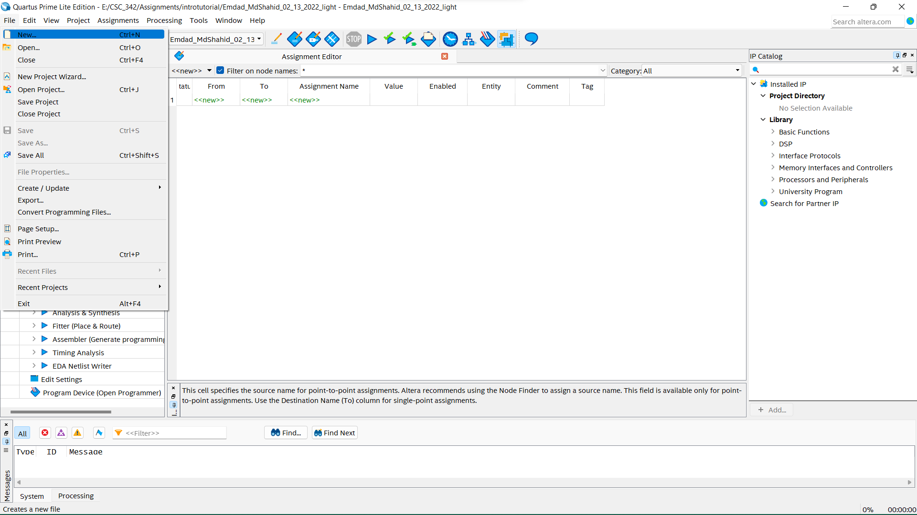

Figure 12: Creating VHDL file

In figure 13, I selected ***VDHL file*** to create the vhdl file.

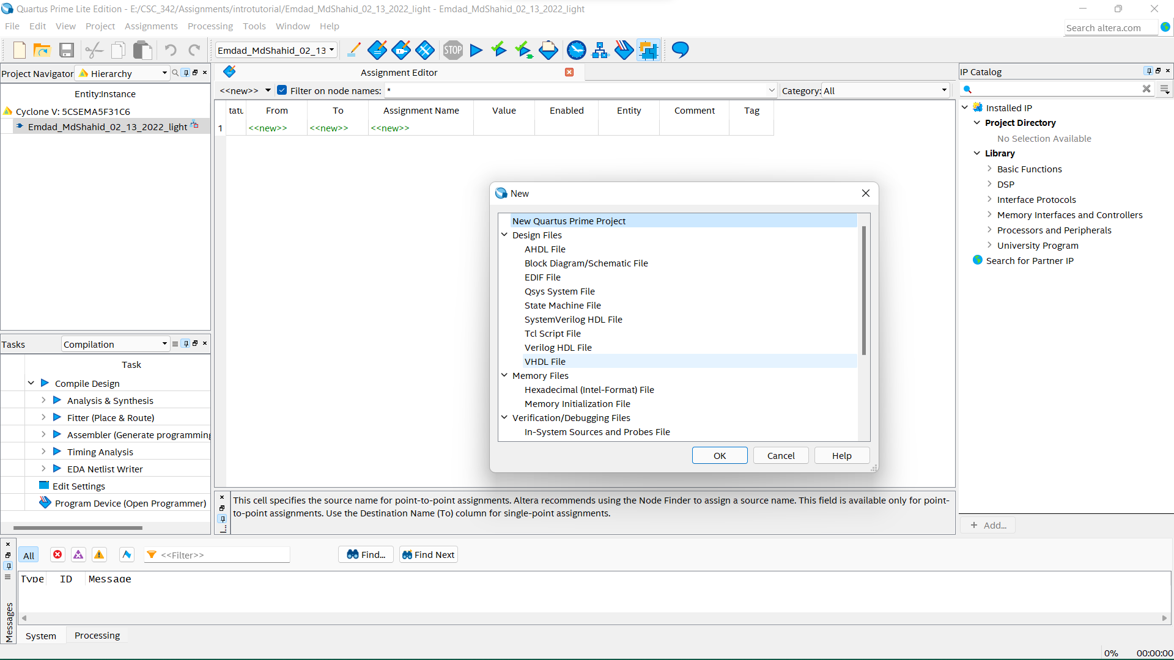

Figure 13: VHDL file selection

In figure 14, I then clicked on ***file*** again to save the VHDL file by renaming with entity.

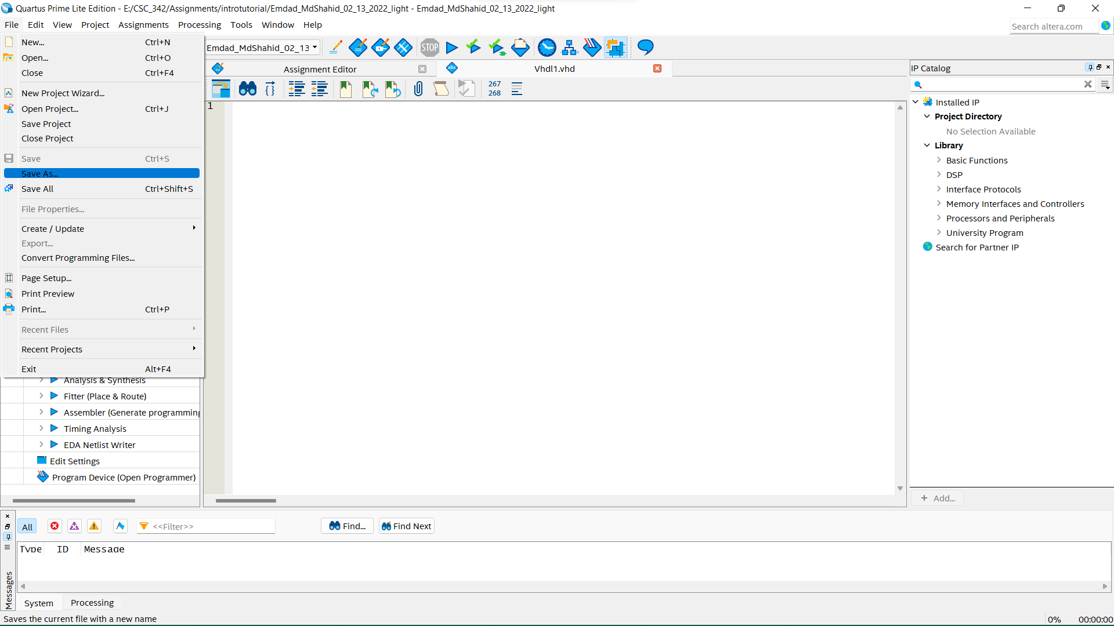

Figure 14: Renaming the VHDL file

In figure 15, I then saved the VHDL file as same as the entity name. I checked on the ***add to the project folder.***

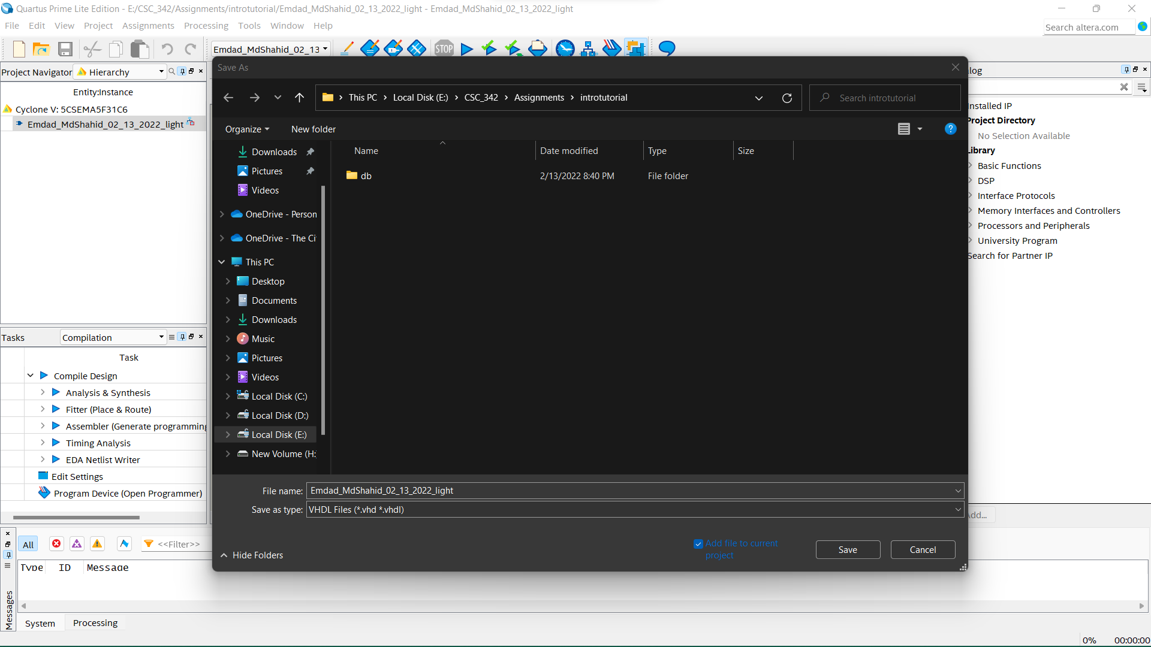

Figure 15: saving the VHDL file

In figure 16, we can see the confirmation message at the bottom about saving the file.

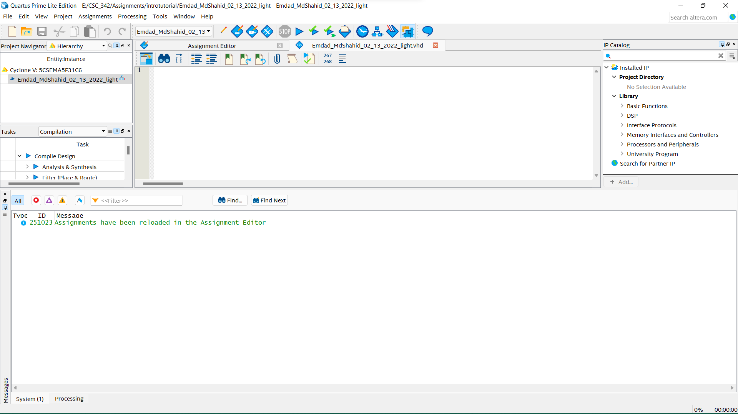

Figure 16: Confirmation about saving the VHDL file

In figure 17, I put my code in the VHDL editor to compile.

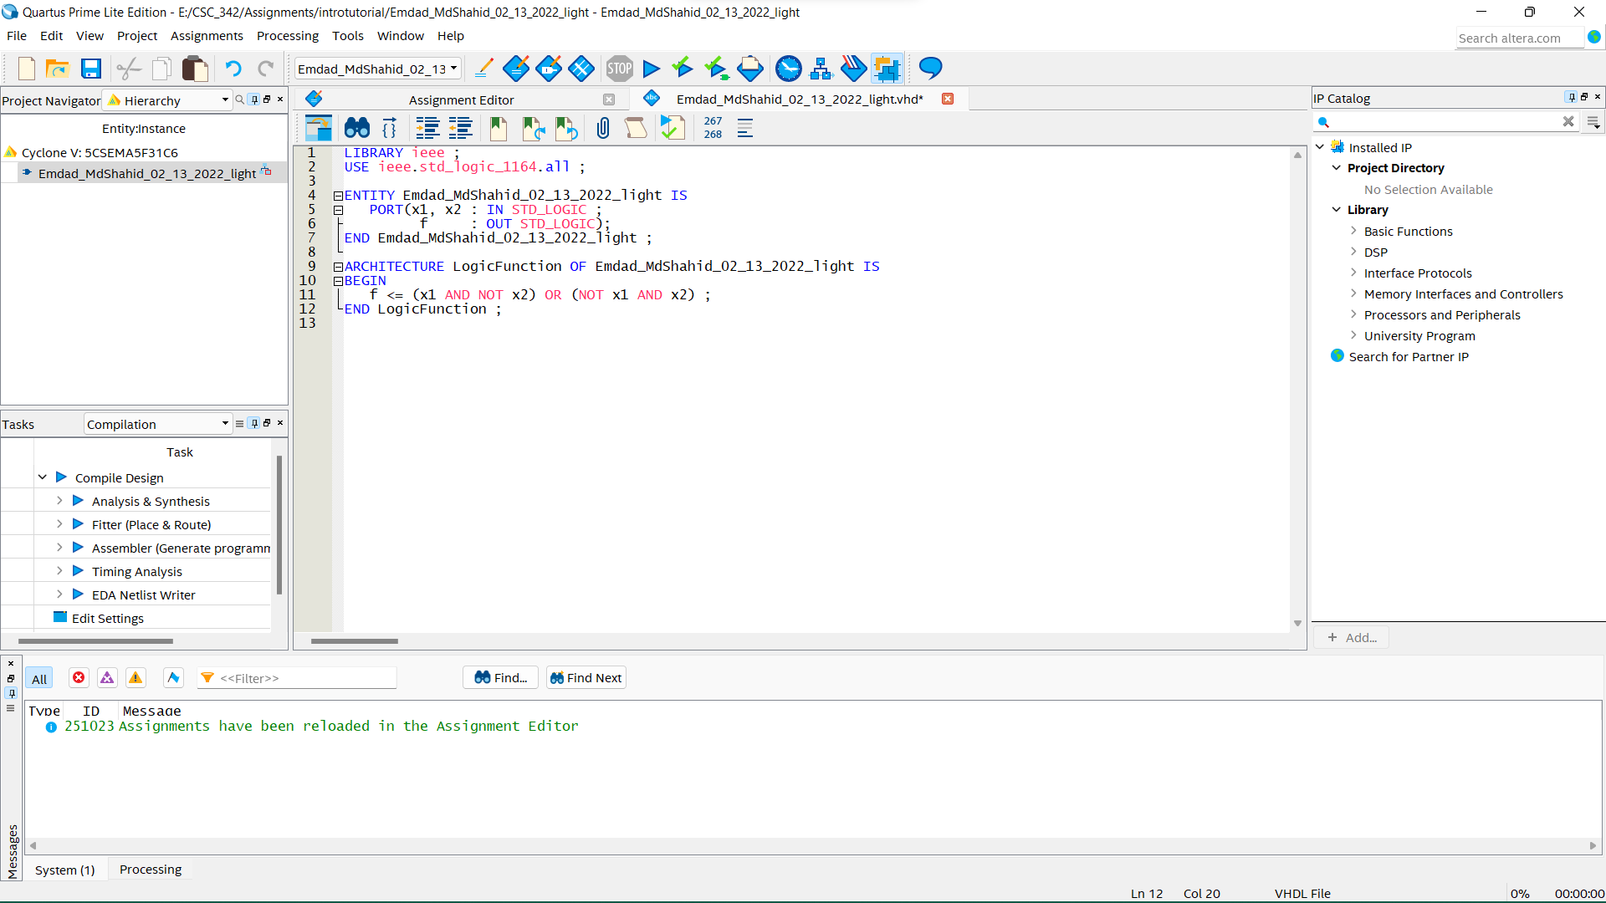

Figure 17: Inserted Code in the editor

In figure 18, I had to save the file to compile.

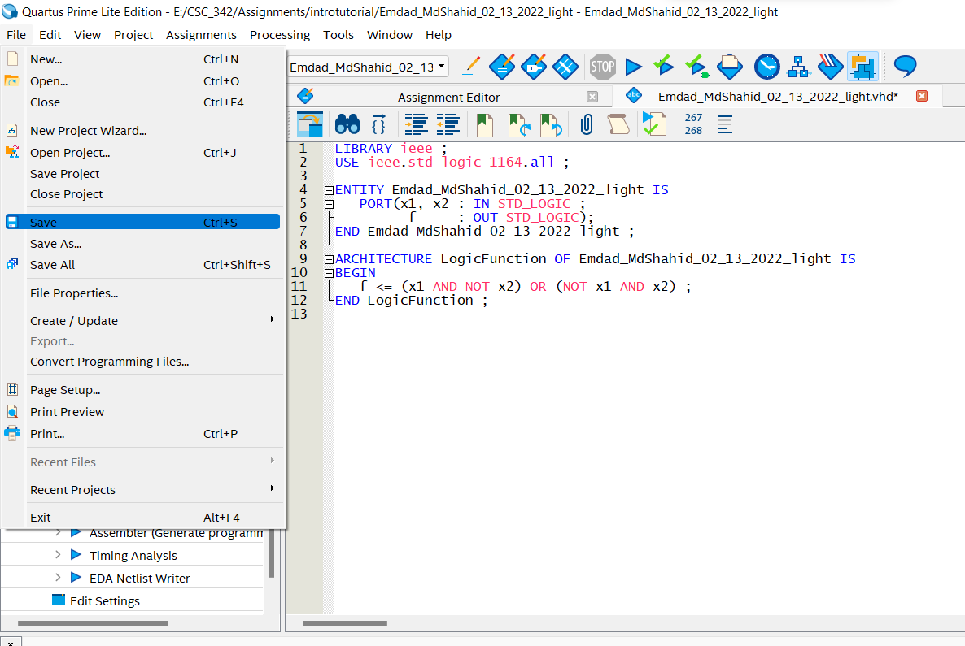

Figure 18: Saving the modified file

In figure 19, I clicked on ***Assignments*** to click on ***Setting***.

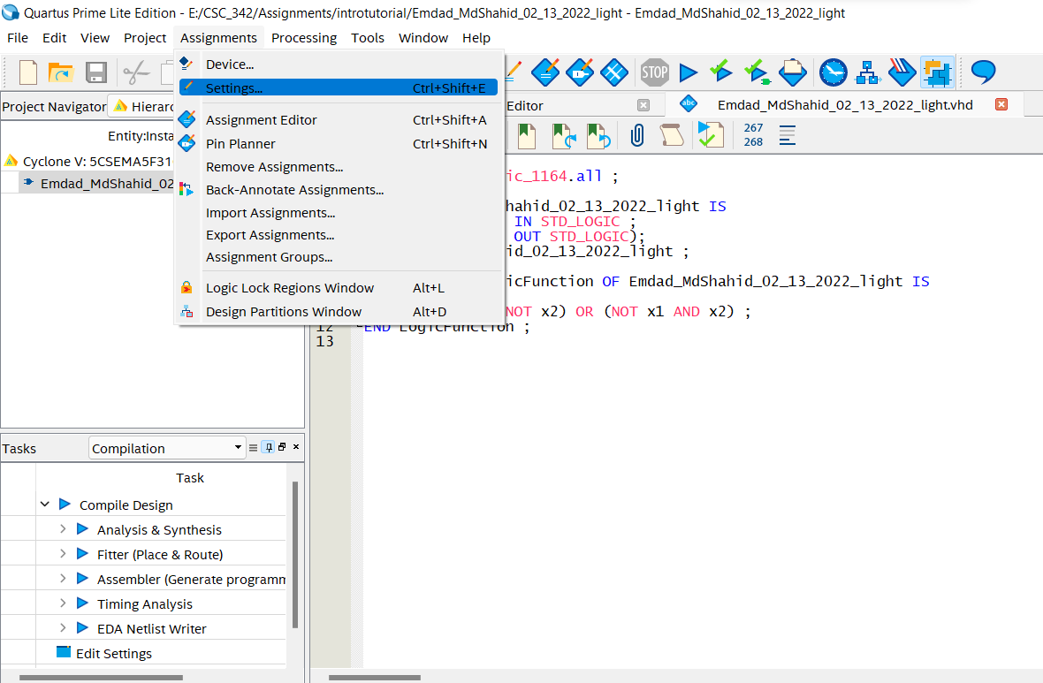

Figure 19: Assignment Setting

In figure 20, I was checking if my VHDL was there so I can compile.

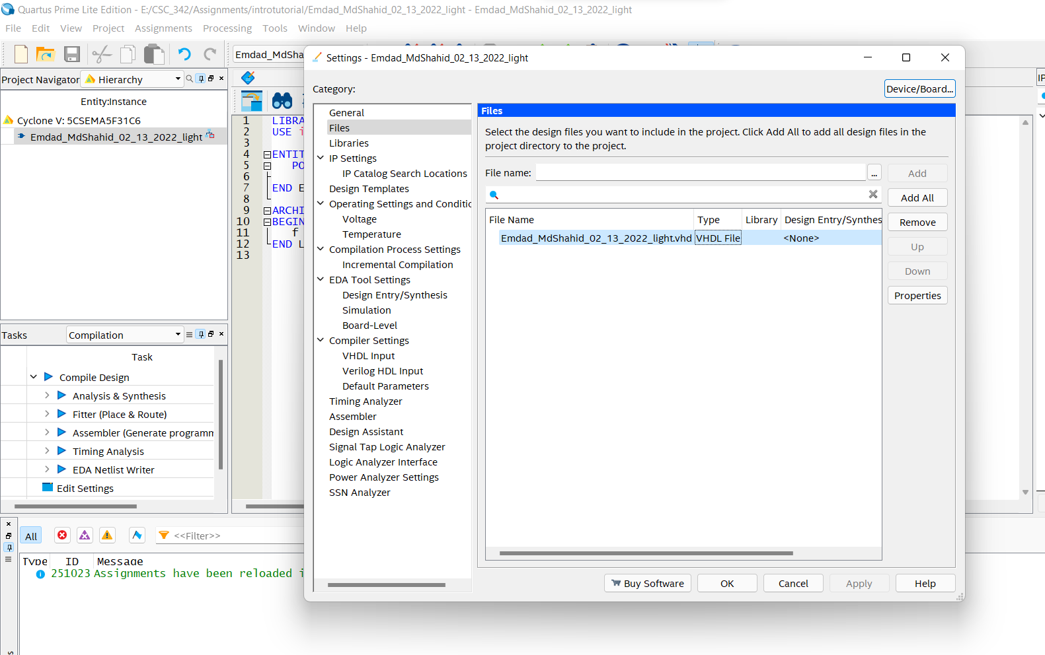

Figure 20: Checking the VHDL file location

In figure 21, I clicked ***Processing*** and then ***Start Compilation*** to compile the program.

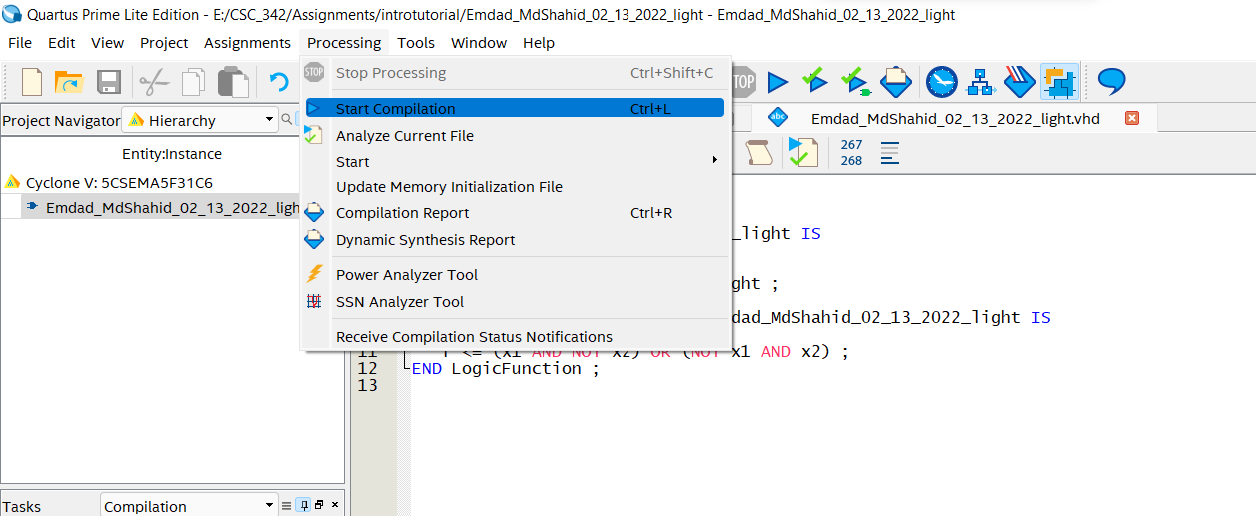

Figure 21: Starting to compile

In figure 22, I can see the compilation report page. How long did it take and all test pass.

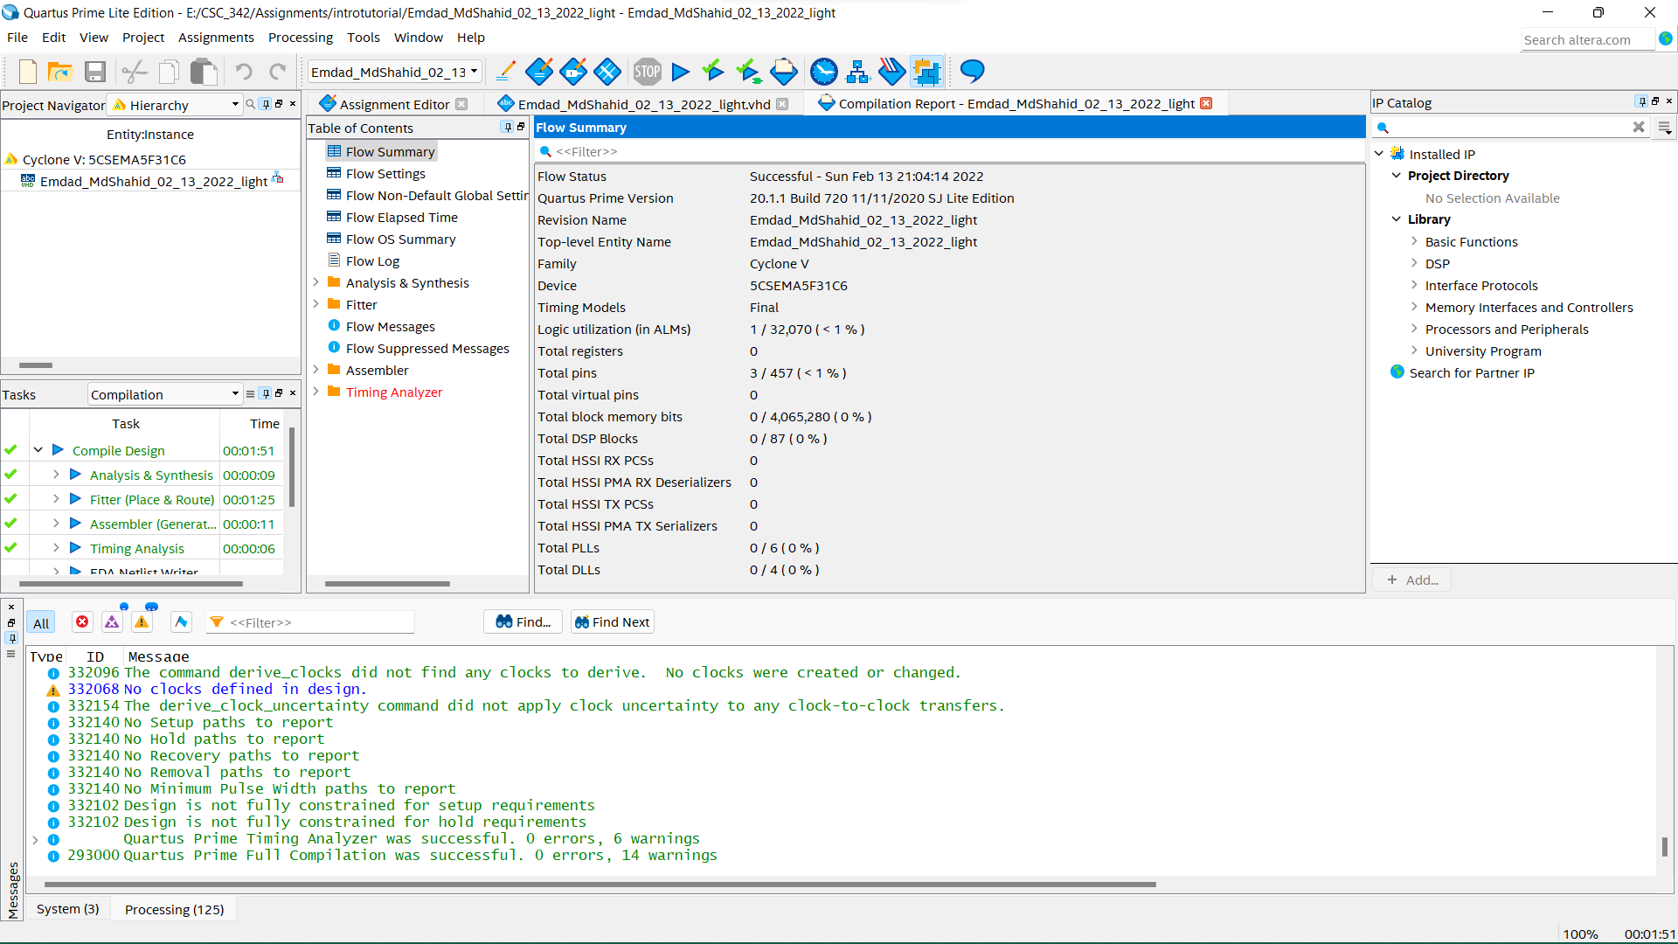

Figure 22: Compilation report

**II. 2:1 mux 1-bit**

To do the 2nd part of the project, I clicked on ***file*** menu again to create ***New Project Wizard***.

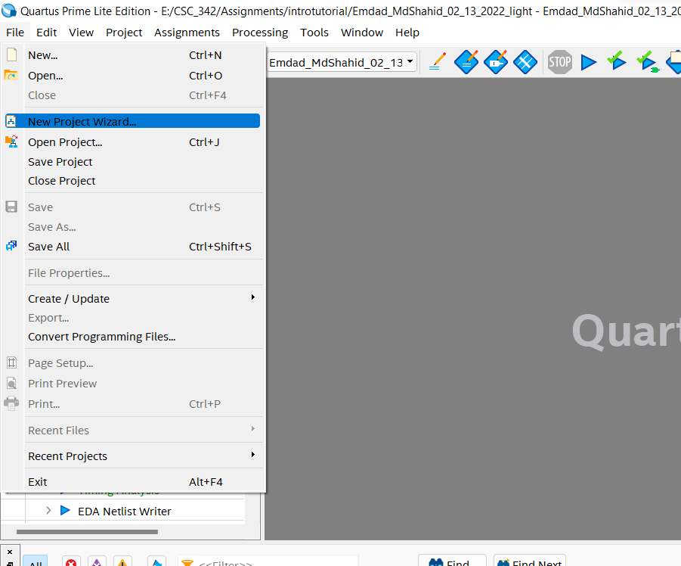

Figure 23: New Project Creation

In figure 24, I then created a separte folder for the project and select the derectory.

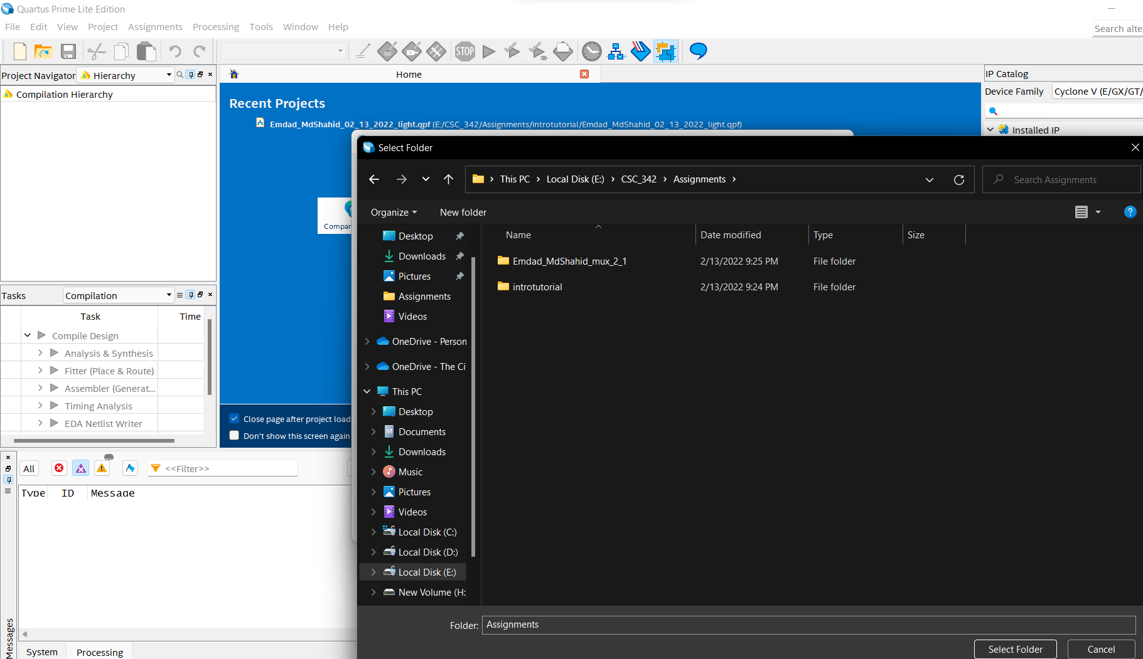

Figure 24: Directory

In figure 25, I chose the directory and gave the entity name ***Emdad_MdShahid_mux_2_1_32bit.***

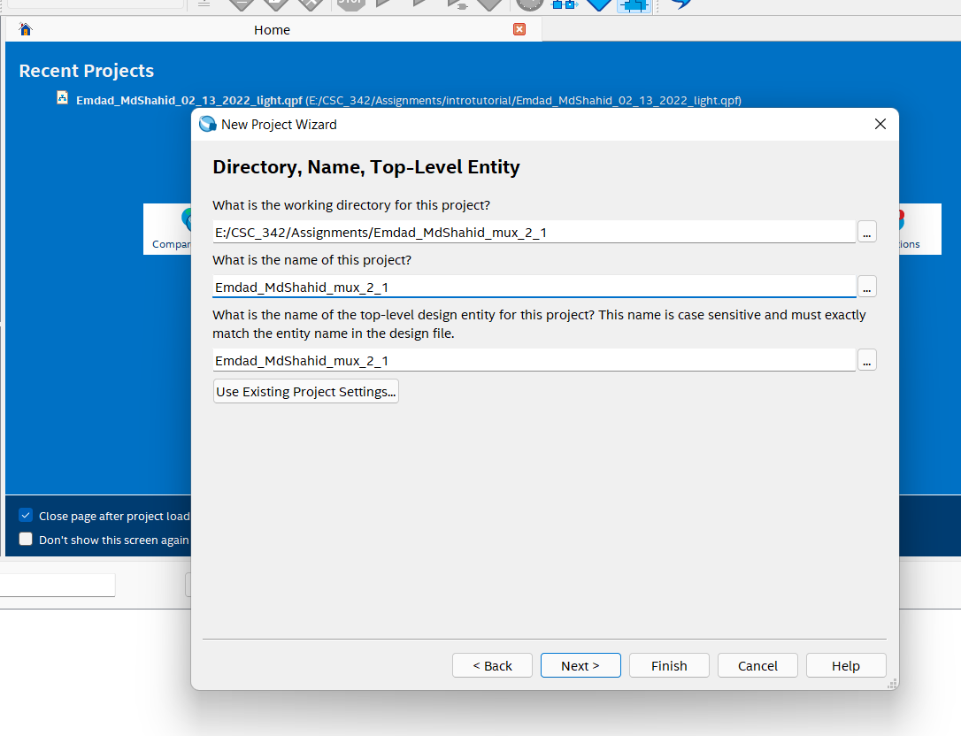

Figure 25: Directory and Entity Name

In figure 26, I can show the summary of project.

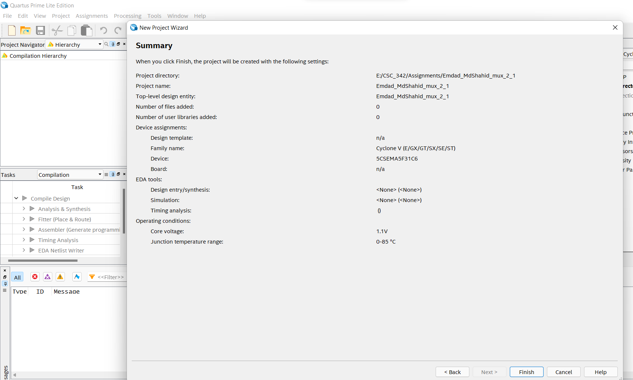

Figure 26: Summary Page

In figure 27, I clicked on the ***file*** menu to create the VHDL file.

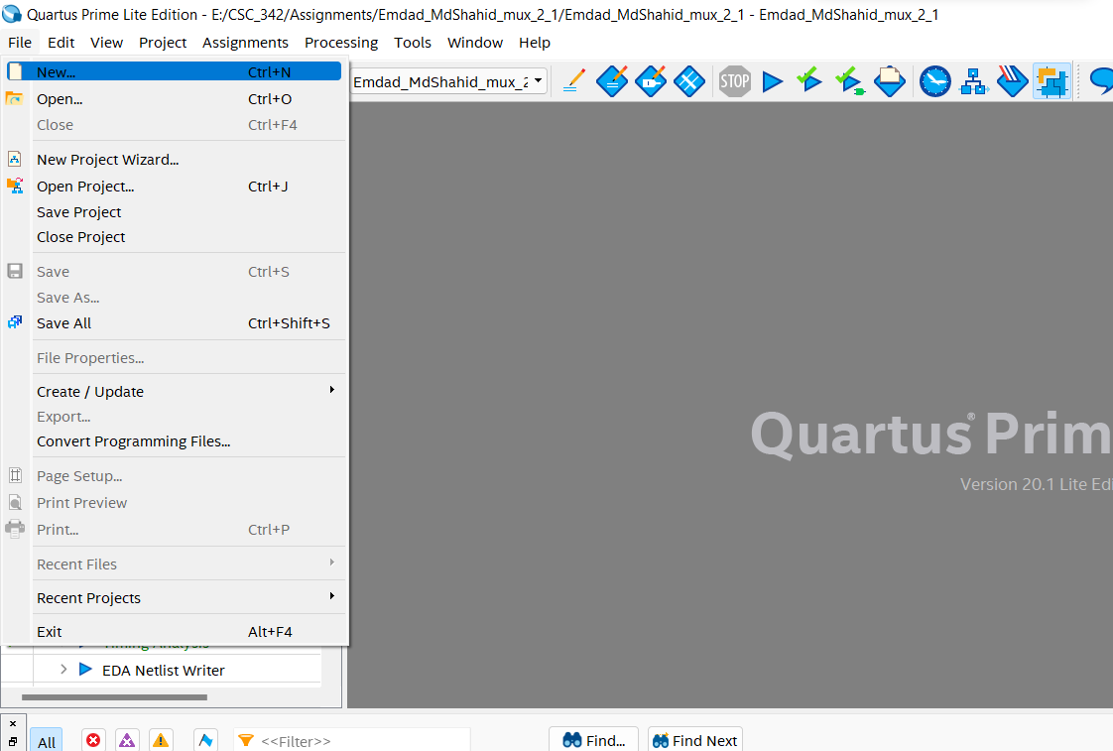

Figure 27: new file

In figure 28, I saved the file in the same directory.

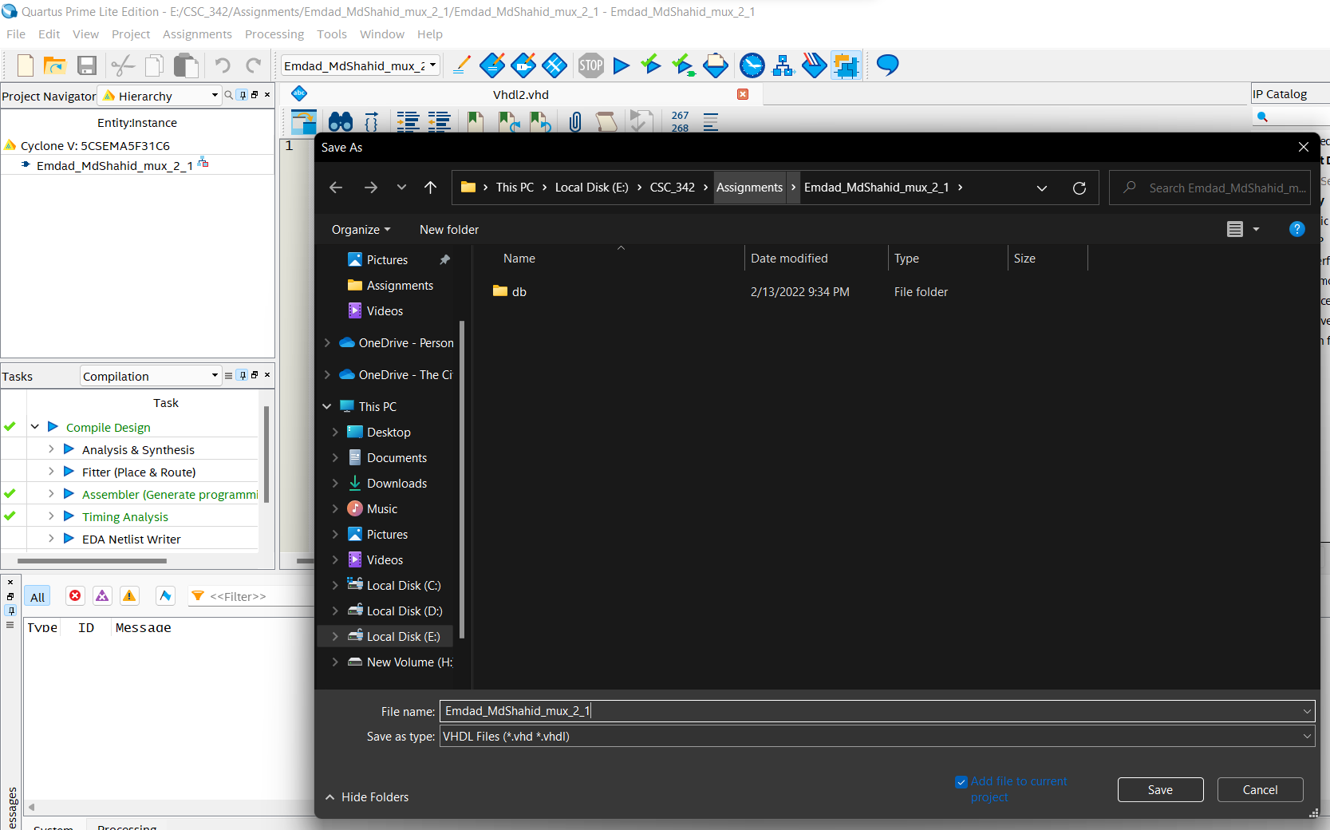

Figure 28: saving file

In figure 29, I wrote my code for the Part B.

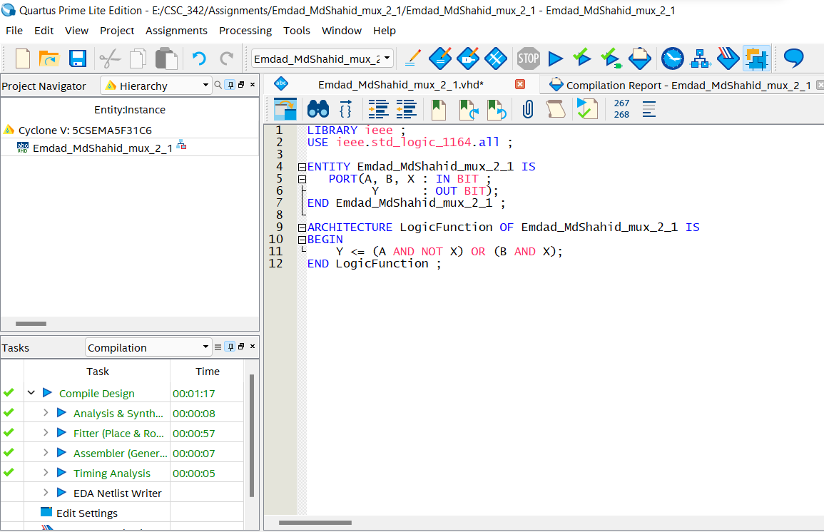

Figure 29: Part B code

In figure 30, we can see the Compilation Report of the Part B project.

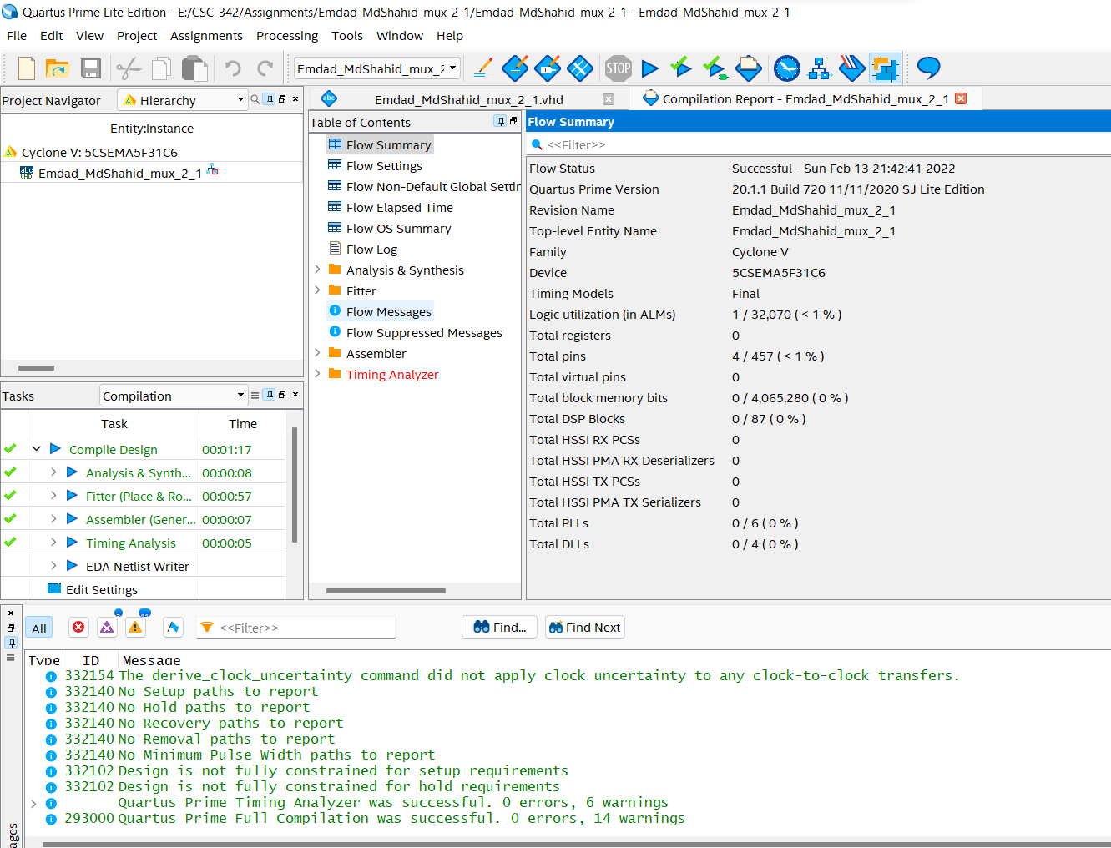

Figure 30: Part B code Compilation Report

**II. 2:1 mux 32-bit**

To do the 3rd part of the project, I clicked on ***file*** menu again to create ***New Project Wizard***. In figure 31, I gave the directory and Entity Name.

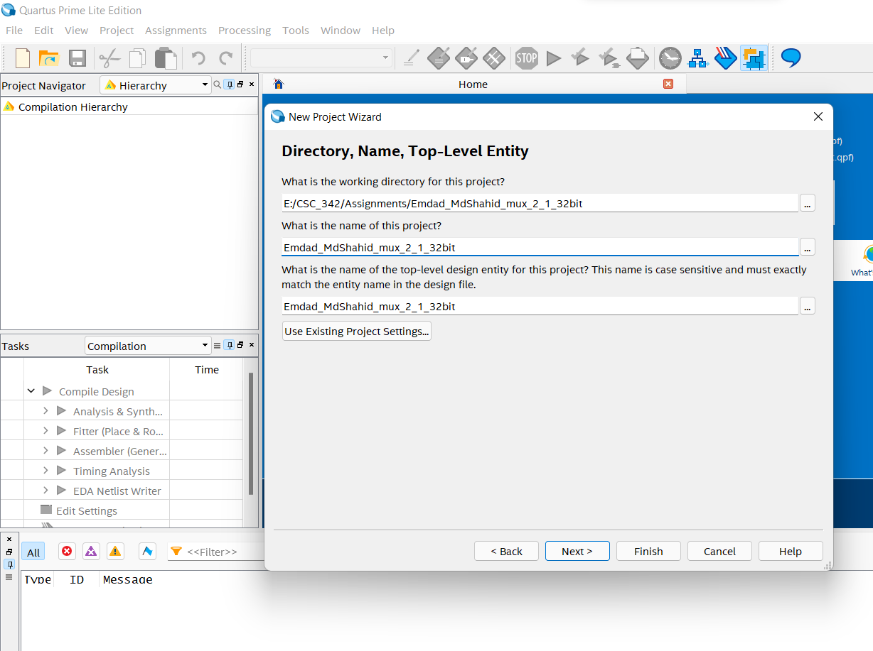

Figure 31: Directory and Entity Name

In figure 32, I wrote my code to compile for Part C.

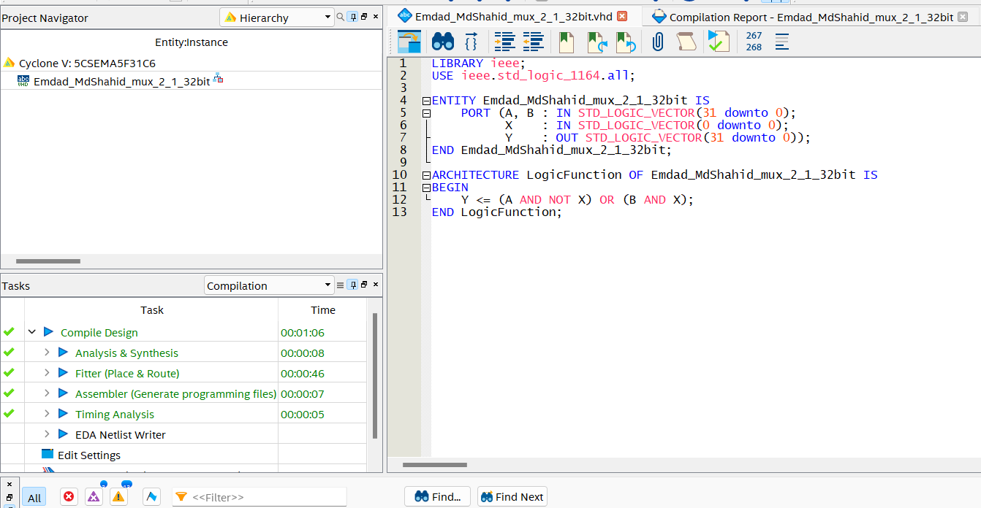

Figure 32: Part C code

In figure 33, We can see the compilation report for the Part C code.

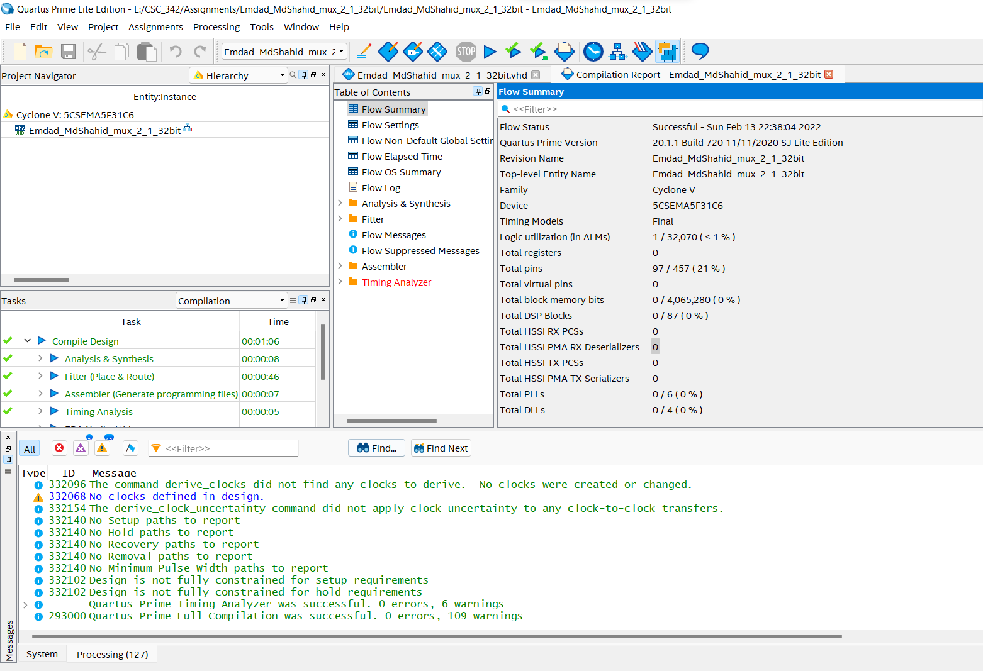

Figure 33: Part C code Compilation Report

# Explanation:

For part A, I totally followed the instructor tutorial. For Part B, I did use the tutorial code and modified the port In and Out as the requirement was to have 2:1 multiplexer but 1 bit. With some internet research, it was easy to and the equation did the job. For Part C, I also did use the tutorial code and modified the port In and Out as the requirement was to have 2:1 multiplexer where each signal is 32 bits and the selector signal is one bit. It was not easy to do as the Quartus software giving error not taking BIT with STD_LOGIC_VECTOR. I used AND and OR gate to compile the program.

# Conclusion:

This assignment was helpful to learn VHDL syntax and code and compile in Quartus software. It was a thorough and brief tutorial to learn the software. The operations and condition logics were helpful to learn easily. I relearned and reviewed the concept again and which will help me in the course further.